Flask app documentation

We create a folder for this project named **flask app**

The final folder directory structure should look like this:

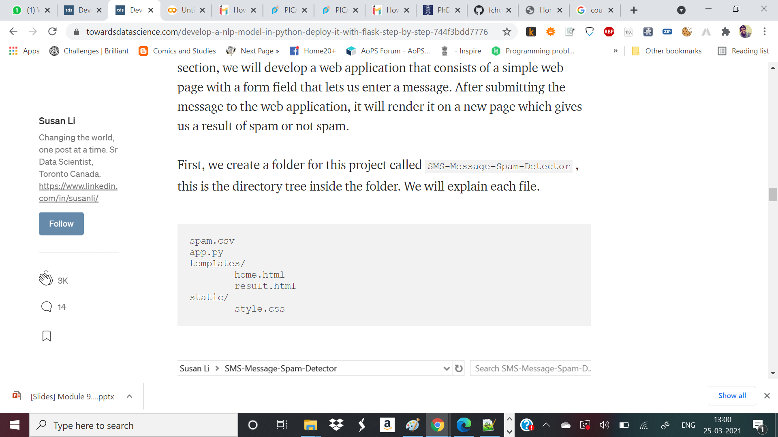

Inside main folder: **flask app**

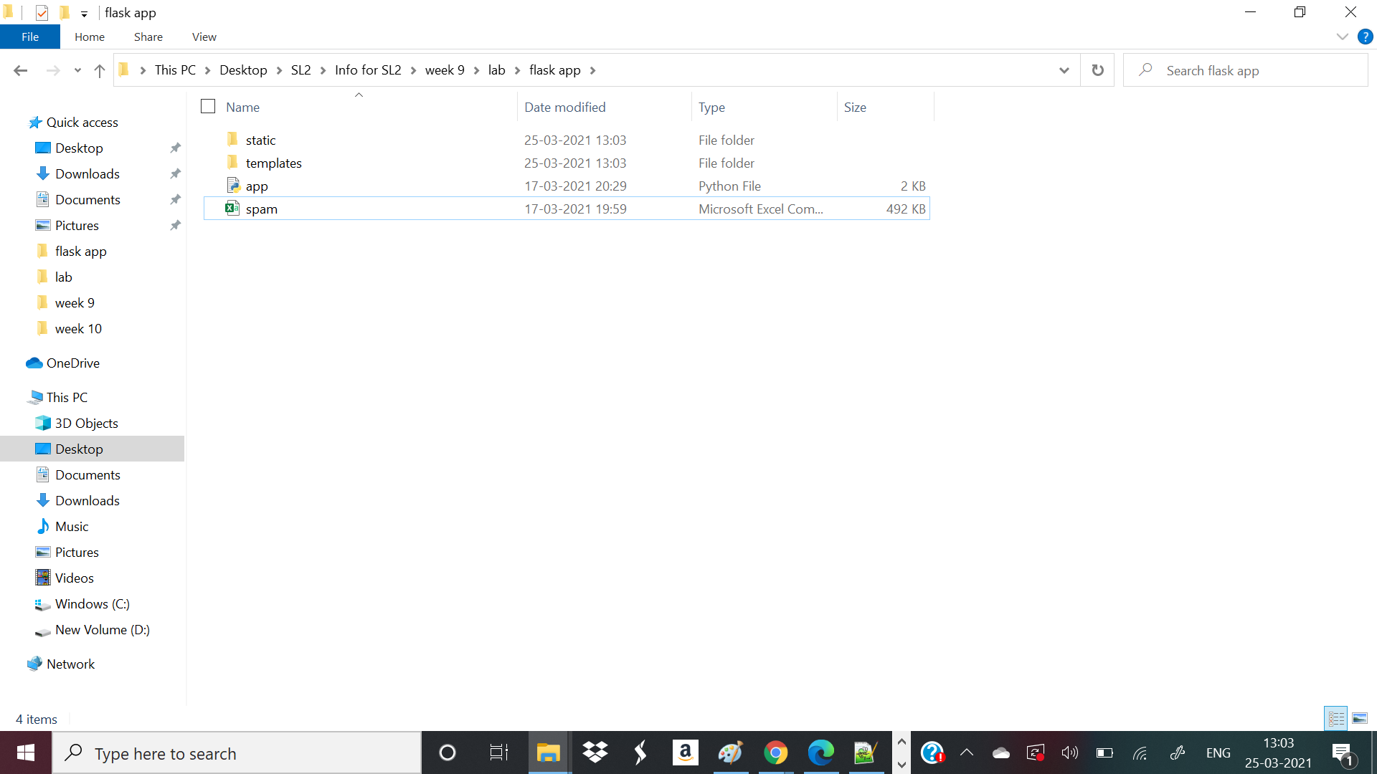

Inside **static** folder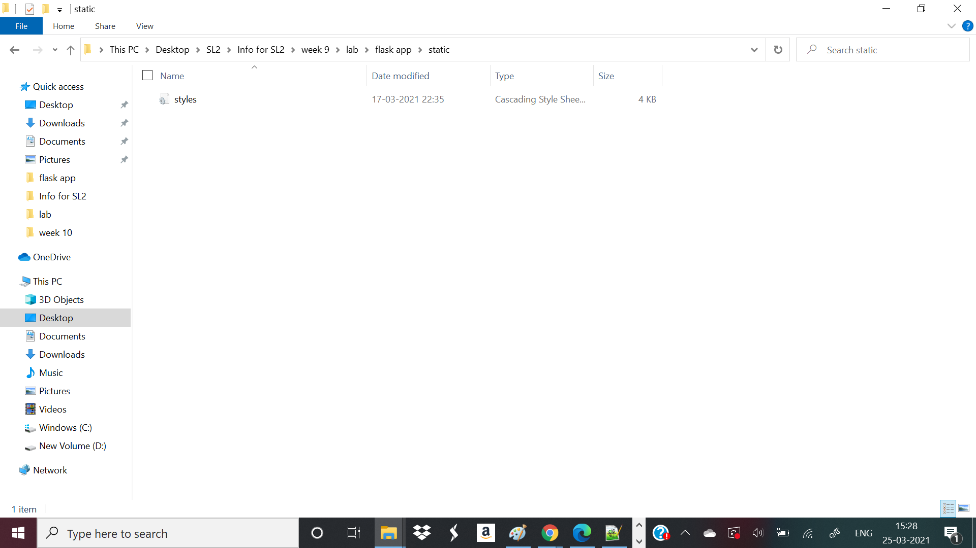

Inside **templates** folder:

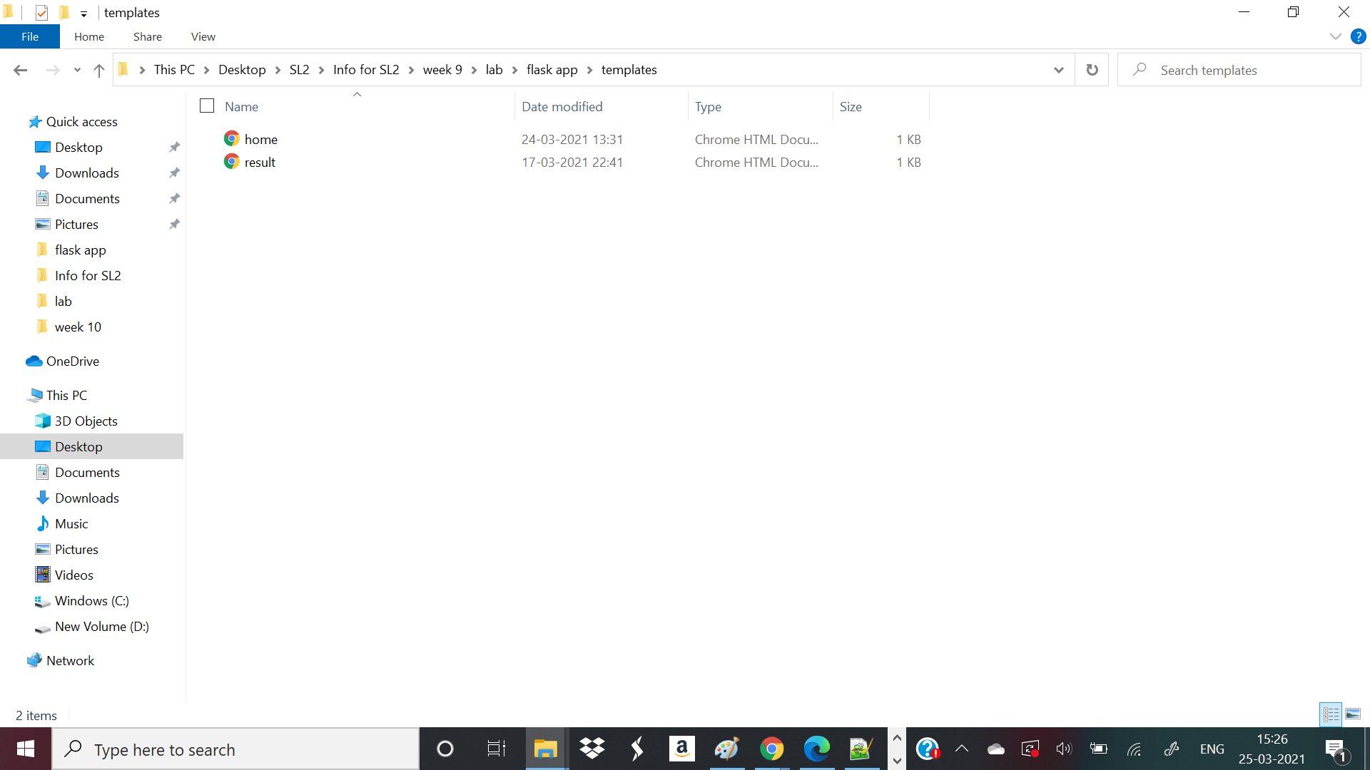

We will see how to create all these files step by step.

App.py file python code:

from flask import Flask,render_template,url_for,request

import pandas as pd

import pickle

from sklearn.feature_extraction.text import CountVectorizer

from sklearn.naive_bayes import MultinomialNB

import joblib

app = Flask(__name__)

@app.route('/')

def home():

return render_template('home.html')

@app.route('/predict',methods=['POST'])

def predict():

df= pd.read_csv("spam.csv", encoding="latin-1")

df.drop(['Unnamed: 2', 'Unnamed: 3', 'Unnamed: 4'], axis=1, inplace=True)

# Features and Labels

df['label'] = df['v1'].map({'ham': 0, 'spam': 1})

X = df['v2']

y = df['label']

# Extract Feature With CountVectorizer

cv = CountVectorizer()

X = cv.fit_transform(X) # Fit the Data

from sklearn.model_selection import train_test_split

X_train, X_test, y_train, y_test = train_test_split(X, y, test_size=0.33, random_state=42)

#Naive Bayes Classifier

from sklearn.naive_bayes import MultinomialNB

clf = MultinomialNB()

clf.fit(X_train,y_train)

clf.score(X_test,y_test)

#Alternative Usage of Saved Model

# joblib.dump(clf, 'NB_spam_model.pkl')

# NB_spam_model = open('NB_spam_model.pkl','rb')

# clf = joblib.load(NB_spam_model)

if request.method == 'POST':

message = request.form['message']

data = [message]

vect = cv.transform(data).toarray()

my_prediction = clf.predict(vect)

return render_template('result.html',prediction = my_prediction)

if __name__ == '__main__':

app.run(debug=True)

**home.html** code:

<!DOCTYPE html>

<html>

<head>

<title>Home</title>

<!-- <link rel="stylesheet" type="text/css" href="../static/css/styles.css"> -->

<link rel="stylesheet" type="text/css" href="{{ url_for('static', filename='styles.css') }}">

</head>

<body style="background-color:powderblue">

<header>

<h2>NLP Deployment with Flask</h2>

<div class="container">

<div id="brandname">

</div>

<br>

<br><h2>Spam Detector For SMS Messages</h2>

</div>

</header>

<br><br>

<div class="form-style-5">

<form action="{{ url_for('predict')}}" method="POST">

<p>Enter Your Message Here</p>

<!-- <input type="text" name="comment"/> -->

<textarea name="message" rows="4" cols="50"></textarea>

<br/>

<input type="submit" value="PREDICT">

</form>

</div>

</body>

</html>

**result.html** code:

<!DOCTYPE html>

<html>

<head>

<title></title>

<link rel="stylesheet" type="text/css" href="{{ url_for('static', filename='styles.css') }}">

</head>

<body style="background-color:powderblue">

<header>

<div class="container">

<div id="brandname">

</div>

<h2>Spam Detector For SMS Messages</h2>

</div>

</header>

<div class="container">

{% if prediction == 1%}

<h2 style="color:red;">Spam</h2>

{% elif prediction == 0%}

<h2 style="color:blue;">Not a Spam (It is a Ham)</h2>

{% endif %}

</div>

</body>

</html>

**styles.css** code:

body{

font:15px/1.5 Arial, Helvetica,sans-serif;

padding: 0px;

background-color:#f4f3f3;

}

.container{

width:100%;

margin: auto;

overflow: hidden;

}

header{

background:#03A9F4;#35434a;

border-bottom:#448AFF 3px solid;

height:120px;

width:100%;

padding-top:30px;

}

h3 {

font-family: Verdana, Arial, Helvetica, sans-serif;

font-size: 13px;

color: #6600FF;

text-align: center;

}

.main-header{

text-align:center;

background-color: blue;

height:100px;

width:100%;

margin:0px;

}

#brandname{

float:left;

font-size:30px;

color: #fff;

margin: 10px;

}

header h2{

text-align:center;

color:#17ad14d1;

}

.btn-info {background-color: #2196F3;

height:40px;

width:100px;} /* Blue */

.btn-info:hover {background: #0b7dda;}

.resultss{

border-radius: 15px 50px;

background: #345fe4;

padding: 20px;

width: 200px;

height: 150px;

}

.form-style-5{

max-width: 500px;

padding: 10px 20px;

background: #f4f7f8;

margin: 10px auto;

padding: 20px;

background: #f4f7f8;

border-radius: 8px;

font-family: Georgia, "Times New Roman", Times, serif;

}

.form-style-5 fieldset{

border: none;

}

.form-style-5 legend {

font-size: 1.4em;

margin-bottom: 10px;

}

.form-style-5 label {

display: block;

margin-bottom: 8px;

}

.form-style-5 input[type="text"],

.form-style-5 input[type="date"],

.form-style-5 input[type="datetime"],

.form-style-5 input[type="email"],

.form-style-5 input[type="number"],

.form-style-5 input[type="search"],

.form-style-5 input[type="time"],

.form-style-5 input[type="url"],

.form-style-5 textarea,

.form-style-5 select {

font-family: Georgia, "Times New Roman", Times, serif;

background: rgba(255,255,255,.1);

border: none;

border-radius: 4px;

font-size: 15px;

margin: 0;

outline: 0;

padding: 10px;

width: 100%;

box-sizing: border-box;

-webkit-box-sizing: border-box;

-moz-box-sizing: border-box;

background-color: #e8eeef;

color:#8a97a0;

-webkit-box-shadow: 0 1px 0 rgba(0,0,0,0.03) inset;

box-shadow: 0 1px 0 rgba(0,0,0,0.03) inset;

margin-bottom: 30px;

}

.form-style-5 input[type="text"]:focus,

.form-style-5 input[type="date"]:focus,

.form-style-5 input[type="datetime"]:focus,

.form-style-5 input[type="email"]:focus,

.form-style-5 input[type="number"]:focus,

.form-style-5 input[type="search"]:focus,

.form-style-5 input[type="time"]:focus,

.form-style-5 input[type="url"]:focus,

.form-style-5 textarea:focus,

.form-style-5 select:focus{

background: #d2d9dd;

}

.form-style-5 select{

-webkit-appearance: menulist-button;

height:35px;

}

.form-style-5 .number {

background: #1abc9c;

color: #fff;

height: 30px;

width: 30px;

display: inline-block;

font-size: 0.8em;

margin-right: 4px;

line-height: 30px;

text-align: center;

text-shadow: 0 1px 0 rgba(255,255,255,0.2);

border-radius: 15px 15px 15px 0px;

}

.form-style-5 input[type="submit"],

.form-style-5 input[type="button"]

{

position: relative;

display: block;

padding: 19px 39px 18px 39px;

color: #FFF;

margin: 0 auto;

background: #1abc9c;

font-size: 18px;

text-align: center;

font-style: normal;

width: 100%;

border: 1px solid #16a085;

border-width: 1px 1px 3px;

margin-bottom: 10px;

}

.form-style-5 input[type="submit"]:hover,

.form-style-5 input[type="button"]:hover

{

background: #109177;

}